Starting Values based on Campaign Level

| ***Level*** | ***CrP Value*** | ***Max Talent Lvl*** | ***Wealth*** | ***Cultural Points*** | ***Attribute Die*** |
| --- | --- | --- | --- | --- | --- |
| Low | 30 | 1 | 250 | 20 | 2d8 |
| Mid | 40 | 2 | 500 | 30 | 2d10 |
| High | 50 | 3 | 1000 | 40 | 2d12 |

*Character Creation*

Step 1: Roll for Attribute Array

* Roll your Campaign level Attribute Die once for each attribute.
* Allocate Attributes rolls.

Step 2: Select Race (Found in Core)

Step 3: Select Birthsign (Found in Core)

* Choose whether you want to be Star-Cursed or not.

Step 4: Select Culture

* Distribute Cultural Skill Points
* Select a Cultural Trait

Step 5: Spend CrP

***Cultures***

When selecting your Culture, you are given your choice of One of the Culture’s traits and are given an amount of skill points that they can divide between their Cultural skills. You cannot put more than half your total starting skill points into a single skill.

*Personalizing your Character*

You are given an allowance of Creation Points (CrP) based on the starting level of the Campaign. You may spend them on the options shown on the charts below and may spend them on Character Traits, or gain some extra CrP by taking some negative Character Traits. Any unspent CrP becomes XP after character creation.

CrP Costs

| ***Advancement*** | ***CrP Cost*** |
| --- | --- |
| Skill Point | (Skill Rank) |
| 1st Level Talent | 5 |
| 2nd Level Talent | 10 |
| 3rd Level Talent | 15 |
| Increase Attribute by 1 | 3*Bonus |
| Learning an Extra Spell ! | 5 |
| Learn a Ritual | 10 |

! = You get 1 Free Spell for every Rank beyond Novice in a Spell School you have.

Skill Ranks and Costs

| ***Skill Rank*** | ***Point Range*** | ***CrP Cost*** |
| --- | --- | --- |
| (1) Novice | 0 - 9 | 1 |
| (2) Apprentice | 10 - 19 | 2 |
| (3) Journeyman | 20 - 29 | 3 |
| (4) Adept | 30 - 39 | 4 |
| (5) Expert | 40 - 49 | 5 |
| (6) Master | 50 | 6 |

***Altmer***

*The High Elves consider themselves the most civilized culture of Tamriel; the common tongue of the Empire, Tamrielic, is based on Altmer speech and writing, and most of the Empire's arts, crafts, and sciences derive from High Elven traditions. Deft, intelligent, and strong-willed, High Elves are often gifted in the arcane arts, and High Elves boast that their sublime physical natures make them far more resistant to disease than the "lesser races."*

**Baseline Attributes**

| ***STR*** | ***END*** | ***AG*** | ***INT*** | ***WP*** | ***PRC*** | ***PRS*** |
| --- | --- | --- | --- | --- | --- | --- |
| 30 | 33 | 33 | 44 | 40 | 35 | 35 |

**Native Tongue:** *Altmeris*

**Traits**

* ***Highborn***

Altmer have a +20 to their Max Magicka and naturally regain lost magicka at twice the normal rate.

* ***Resist Disease (2)***

The character gains a +20 on Endurance tests made to resist contracting disease or having a disease worsen.

* ***Weakness (Magic, 3)***

The character takes 3 extra damage from sources of harmful spells and takes a -30 on Willpower tests made to resist non-damaging spells.

* ***Mental Strength***

Altmer ignore all penalties to Willpower tests made to resist magic.

***Argonian, Saxhleel***

*At home in water and on land, the Argonians of Black Marsh are well-suited to the treacherous swamps of their homeland, with natural immunities protecting them from disease and poison. The female life-phase is highly intelligent, and gifted in the magical arts. The more aggressive male phase has the traits of the hunter: stealth, speed, and agility. Argonians are reserved with strangers, yet fiercely loyal to those they accept as friends.*

**Baseline Attributes**

| ***STR*** | ***END*** | ***AG*** | ***INT*** | ***WP*** | ***PRC*** | ***PRS*** |
| --- | --- | --- | --- | --- | --- | --- |
| 36 | 35 | 39 | 37 | 35 | 36 | 32 |

**Native Tongue:** *Jel*

**Traits**

* ***Amphibious***

Argonians can breathe water and ignore all penalties to combat rolls due to swimming. Additionally, their swim speed is doubled.

* ***Resist Disease (5)***

The character gains a +50 on Endurance tests made to resist contracting disease or having a disease worsen.

* ***Immunity (Poison)***

The character is immune to the effects of poison.

* ***Reptilian Metabolism***

The Argonian doubles the duration of all effects from consumables, such as Food, Drink, and Potions. If the consumable lacks a duration, increase the numerical effect by 2.

***Bosmer***

*The Wood Elves are the various barbarian Elven clanfolk of the Western Valenwood forests. These country cousins of the High Elves and Dark Elves are nimble and quick in body and wit, and because of their curious natures and natural agility, Wood Elves are especially suitable as scouts, agents, and thieves. But most of all, the Wood Elves are known for their skills with bows; there are no finer archers in all of Tamriel.*

**Baseline Attributes**

| ***STR*** | ***END*** | ***AG*** | ***INT*** | ***WP*** | ***PRC*** | ***PRS*** |
| --- | --- | --- | --- | --- | --- | --- |
| 31 | 31 | 41 | 35 | 33 | 44 | 35 |

**Native Tongue:** *Bosmeris*

**Traits**

* ***Beast Tongue***

Bosmer can speak to, and understand the speech of, animals.

* ***Hunter’s Eye***

Bosmer add +3 damage each time they take the “Aim” action instead of +2.

* ***Resist Disease (3)***

The character gains a +30 on Endurance tests made to resist contracting disease or having a disease worsen.

* ***Resist Poison (1)***

The character takes 1 less damage from sources of Poison damage and gains a +10 on tests made to resist the effects of non-damaging poisons.

***Breton***

*Passionate and eccentric, poetic and flamboyant, intelligent and willful, the Bretons feel an inborn, instinctive bond with the mercurial forces of magic and the supernatural. Many great sorcerers have come out of their home province of High Rock, and in addition to their quick and perceptive grasp of spellcraft, enchantment, and alchemy, even the humblest of Bretons can boast a high resistance to destructive and dominating magical energies.*

**Baseline Attributes**

| ***STR*** | ***END*** | ***AG*** | ***INT*** | ***WP*** | ***PRC*** | ***PRS*** |
| --- | --- | --- | --- | --- | --- | --- |
| 33 | 32 | 32 | 38 | 43 | 35 | 37 |

**Native Tongue:** *Bretonic*

**Traits**

* ***Elven Heritage***

Bretons gain a +10 to their Max Magicka and reduce the Magicka costs of all spells they cast by 1.

* ***Gift of Magnus***

Bretons increase their max Attunement by 1.

* ***Resist Magic (2)***

The character takes 2 less damage from all harmful spells and gains a +20 on Willpower tests made to resist the effects of non-damaging spells.

***Dunmer***

*In the Empire, "Dark Elves" is the common usage, but in their Morrowind homeland, they call themselves the "Dunmer". The dark-skinned, red-eyed Dark Elves combine powerful intellect with strong and agile physiques, producing superior warriors and sorcerers. On the battlefield, Dark Elves are noted for their skilled and balanced integration of swordsmen, marksmen, and war wizards. In character, they are grim, distrusting, and disdainful of other races.*

**Baseline Attributes**

| ***STR*** | ***END*** | ***AG*** | ***INT*** | ***WP*** | ***PRC*** | ***PRS*** |
| --- | --- | --- | --- | --- | --- | --- |
| 35 | 35 | 39 | 35 | 37 | 36 | 33 |

**Native Tongue:** *Dunmeris*

**Traits**

* ***Ancestral Guardian***

Once per Short rest, the Dunmer may gain a +3 to the DoS of their next Defensive reaction as a free action.

* ***Ruination***

Dunmer may choose to treat their attacks damage as if it were either Physical or Fire for weaknesses and Damage type effects.

* ***Resist Fire (4)***

The character takes 4 less damage from sources of Fire damage and gains a +40 on tests made to resist the effects of the heat.

***Imperial***

*The well-educated and well-spoken natives of Cyrodiil are known for the discipline and training of their citizen armies. Though physically less imposing than the other races, Imperials are shrewd diplomats and traders, and these traits, along with their remarkable skill and training as light infantry, have enabled them to subdue all the other nations and races, and to have erected the monument to peace and prosperity that comprises the Glorious Empire.*

**Baseline Attributes**

| ***STR*** | ***END*** | ***AG*** | ***INT*** | ***WP*** | ***PRC*** | ***PRS*** |
| --- | --- | --- | --- | --- | --- | --- |
| 36 | 37 | 34 | 35 | 36 | 35 | 37 |

**Native Tongue:** *Cyrodilic*

**Traits**

* ***Star of the West***

Imperials gain a +1 to their Max Stamina and regain 1 extra Stamina when resting.

* ***Red Diamond***

The first 3 times an Imperial gains Master rank in a skill, you get to pick one of the following bonuses. You can take the same bonus multiple times.

* +1 Max Stamina
* +3 Max Health
* +5 Max Magicka
* ***Imperial Luck***

Imperials gain one extra Lucky Number.

* ***Imperial Mettle***

Imperials gain +1 Experience Point for “Defeating a Challenging Foe”

***Khajiit, Suthay-Raht***

*The Khajiit of Elsweyr can vary in appearance from nearly Elven Ohmes to the Cathay-Raht "jaguar men" to the great Senche-Tiger. The most common breed found outside of Elsweyr, the suthay-raht, is intelligent, quick, and agile. Khajiit of all breeds have a weakness for sweets, especially the drug known as skooma. Many Khajiit disdain weapons in favor of their natural claws. They make excellent thieves due to their natural agility and unmatched acrobatics ability.*

**Baseline Attributes**

| ***STR*** | ***END*** | ***AG*** | ***INT*** | ***WP*** | ***PRC*** | ***PRS*** |
| --- | --- | --- | --- | --- | --- | --- |
| 32 | 32 | 45 | 35 | 31 | 39 | 36 |

**Native Tongue:** *Ta’Agra*

**Traits**

* ***Eye of Night***

Khajiit can see perfectly in conditions of total darkness and suffer no penalty from conditions of dim or no light.

* ***Suthay Grace***

The Suthay move with such grace and precision that they cannot be knocked prone, unless they were denied their test to resist and gain a +2 to their Move Speed. (Such as being stunned)

* ***Clawed***

Unarmed attacks have the Slashing quality.

***Nord***

*The citizens of Skyrim are aggressive and fearless in war, industrious and enterprising in trade and exploration. Strong, stubborn, and hardy, Nords are famous for their resistance to cold, even magical frost. Violence is an accepted and comfortable aspect of Nord culture; Nords of all classes are skilled with a variety of weapon and armor styles, and they cheerfully face battle with an ecstatic ferocity that shocks and appalls their enemies.*

**Baseline Attributes**

| ***STR*** | ***END*** | ***AG*** | ***INT*** | ***WP*** | ***PRC*** | ***PRS*** |
| --- | --- | --- | --- | --- | --- | --- |
| 43 | 39 | 33 | 31 | 34 | 36 | 34 |

**Native Tongue:** *Nordic*

**Traits**

* ***Thunderfist***

Nords inflict +4 damage per Stamina point instead of +3 when Power Attacking.

* ***Resist Frost (2)***

The character takes 2 less damage from sources of Frost damage and gains a +20 on tests made to resist the effects of the cold.

* ***Resist Shock (1)***

The character takes 1 less damage from sources of Shock damage.

* ***Stalwart***

Nords gain a +10 on Endurance Tests made to resist wounds.

***Orsimer***

*These sophisticated barbarian beast peoples of the Wrothgarian and Dragontail Mountains are noted for their unshakeable courage in war and their unflinching endurance of hardships. Orc warriors in heavy armor are among the finest front-line troops in the Empire. Most Imperial citizens regard Orc society as rough and cruel, but there is much to admire in their fierce tribal loyalties and generous equality of rank and respect among the sexes.*

**Baseline Attributes**

| ***STR*** | ***END*** | ***AG*** | ***INT*** | ***WP*** | ***PRC*** | ***PRS*** |
| --- | --- | --- | --- | --- | --- | --- |
| 39 | 43 | 33 | 33 | 36 | 34 | 32 |

**Native Tongue:** *Orcish*

**Traits**

* ***Pariah’s Pride***

Orcs gain +5 to their Max Health and regain 1 additional Health Point whenever they naturally regain Health.

* ***Unflinching***

Orcs may test Endurance instead of Willpower to resist Fear effects.

* ***Resist Magic (1)***

The character takes 1 less damage from all harmful spells and gains a +10 on Willpower tests made to resist the effects of non-damaging spells.

***Redguard***

*The most naturally talented warriors in Tamriel, the dark-skinned, wiry-haired Redguards of Hammerfell seem born to battle, though their pride and fierce independence of spirit makes them more suitable as scouts or skirmishers, or as free-ranging heroes and adventurers, than as rank-and-file soldiers. In addition to their cultural affinities for many weapon and armor styles, Redguards are also physically blessed with hardy constitutions and quickness of foot.*

**Baseline Attributes**

| ***STR*** | ***END*** | ***AG*** | ***INT*** | ***WP*** | ***PRC*** | ***PRS*** |
| --- | --- | --- | --- | --- | --- | --- |
| 37 | 38 | 37 | 33 | 34 | 37 | 35 |

**Native Tongue:** *Yoku*

**Traits**

* ***Adrenaline Rush***

Once per Short Rest, the Redguard may regain 2 Stamina as a free action while in combat. Additionally, you ignore the passive effects of Major and Minor wounds for the duration of the combat.

* ***Resist Disease (3)***

The character gains a +30 on Endurance tests made to resist contracting disease or having a disease worsen.

* ***Resist Poison (1)***

The character takes 1 less damage from sources of Poison damage and gains a +10 on tests made to resist the effects of non-damaging poisons.

***Race Name***

*Insert Lore Article*

**Baseline Attributes**

| ***STR*** | ***END*** | ***AG*** | ***INT*** | ***WP*** | ***PRC*** | ***PRS*** |
| --- | --- | --- | --- | --- | --- | --- |
|  |  |  |  |  |  |  |

**Native Tongue:** *???*

**Traits**

***Birthsigns***

* *The Mage*

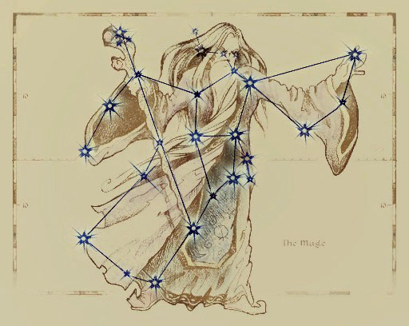

*The Mage is a Guardian Constellation whose Season is Rain's Hand when magicka was first used by men. His Charges are the Apprentice, the Golem, and the Ritual. Those born under the Mage have more magicka and talent for all kinds of spellcasting, but are often arrogant and absent-minded.*

* *Trait*: **Fay**

Gain Power Well (10)

* *Star-Cursed Trait*: **Arcanum**

You restore 1d12 extra Magicka on Short rests, but cannot regain Stamina over short rests.

* *The Apprentice*

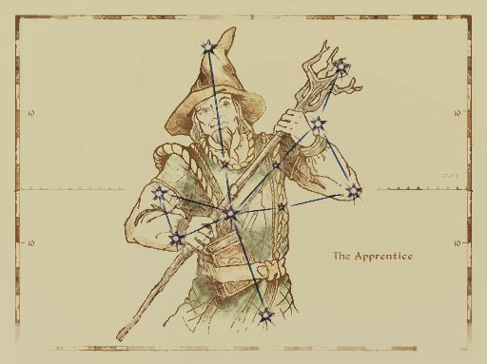

*The Apprentice's Season is Sun's Height. Those born under the sign of the apprentice have a special affinity for magick of all kinds, but are more vulnerable to magick as well.*

* *Trait*: **Elfborn**

Gain Power Well (20) and Weakness (Magic, 1)

* *Star-Cursed Trait*: **Void Seed**

Increases the Weakness to magic by 1, but you now inflict +2 damage with all of your damaging spells.

* *The Atronach*

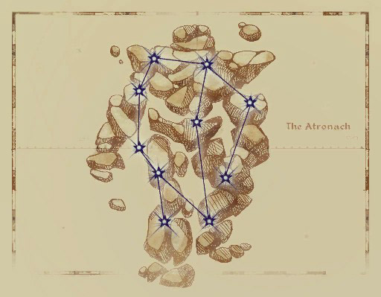

*The Atronach (often called the Golem) is one of the Mage's Charges. Its season is Sun's Dusk. Those born under this sign are natural sorcerers with deep reserves of magicka, but they cannot generate magicka of their own.*

* *Trait*: **Stunted Magicka**

You gain Power Well (30) but you only regain half your Magicka on long rests and none on short rests.

* *Star-Cursed Trait*: **Wombburn**

You gain Power Well (50) instead and cannot naturally regain magicka. However, every time you are affected by a spell cast by someone else, you regain Magicka equal to half the magicka it cost to cast that spell.

* *The Ritual*

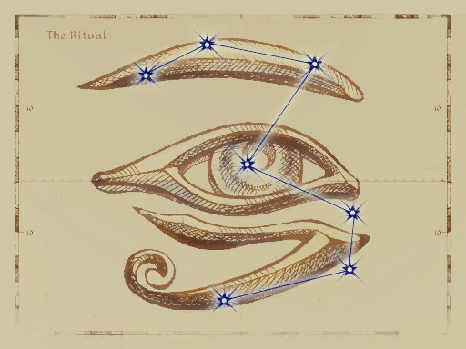

*The Ritual is one of the Mage's Charges and its Season is Morning Star. Those born under this sign have a variety of abilities depending on the aspects of the moons and the Divines.*

* *Trait*: **Mother’s Gift**

You gain +1 to your max Attunement.

* *Star-Cursed Trait*: **Blessed Touch**

Whenever you restore Health to yourself or another through a spell or through Medical treatment, you restore an additional 2 HP. However, you take a -5 to your max Health

* *The Thief*

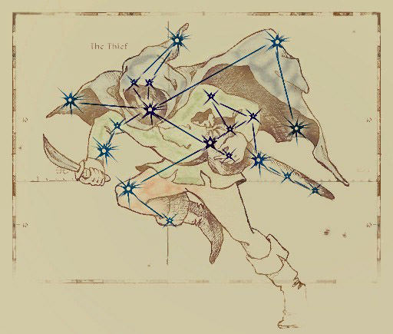

*The Thief is the last Guardian Constellation, and her Season is the darkest month of Evening Star. Her Charges are the Lover, the Shadow, and the Tower. Those born under the sign of the Thief are not typically thieves, though they take risks more often and only rarely come to harm. They will run out of luck eventually, however, and rarely live as long as those born under other signs.*

* *Trait*: **Danger Sense**

You gain +2 to your Initiative.

* *Star-Cursed Trait*: **Ill-Fortune**

Your Luck is set to 50 by default, but you gain 2 Unlucky Numbers that will stay with you forever.

* *The Lover*

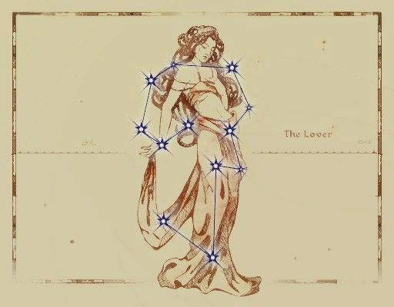

*The Lover is one of the Thief's Charges and her season is Sun's Dawn. Those born under the sign of the Lover are graceful and passionate.*

* *Trait*: **Mooncalf**

You gain +1 Max Stamina

* *Star-Cursed Trait*: **Lover’s Kiss ???**

Once per short rest, you can give away your unspent Stamina to a target that you can physically touch. However your Max HP is reduced by 5.

* *The Tower*

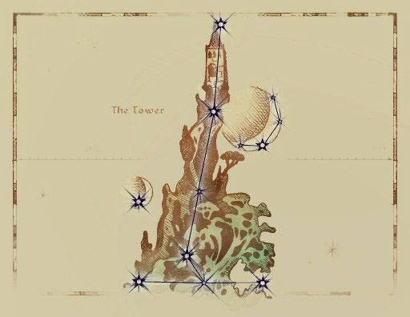

*The Tower is one of the Thief's Charges and its Season is Frostfall. Those born under the sign of the Tower have a lucky streak.*

* *Trait*: **Beggar’s Nose**

You gain +1 Lucky Number.

* *Star-Cursed Trait*: **Tower Key**

You have +1 Max Luck Point, but you lose 2 Additional Luck whenever you burn luck.

* *The Shadow*

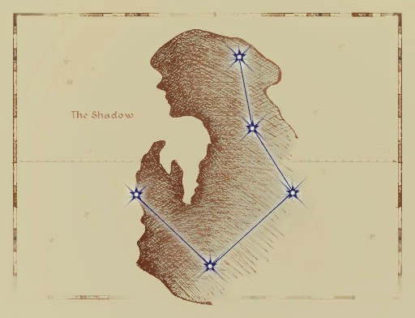

*The Shadow's Season is Second Seed. The Shadow grants those born under her sign the ability to hide in shadows.*

* *Trait*: **Shroud**

You gain +1 DoS on tests made to hide, go unnoticed, or move silently.

* *Star-Cursed Trait*: **Moonshadow ???**

Once per short rest, you can automatically pass your next Sneak test with a DoS equal to your Agility Bonus while in relative darkness. However, your speed while sneaking is reduced by 3.

* *The Warrior*

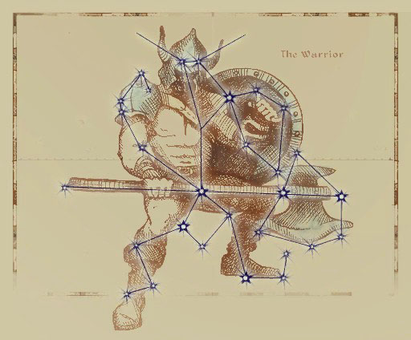

*The Warrior is the first Guardian Constellation and he protects his charges during their Seasons. The Warrior's own season is Last Seed when his Strength is needed for the harvest. His Charges are the Lady, the Steed, and the Lord. Those born under the sign of the Warrior are skilled with weapons of all kinds, but prone to short tempers.*

* *Trait*: **Iron Hand**

You inflict +1 damage on all physical attacks.

* *Star-Cursed Trait*: **Warwyrd**

You inflict +2 damage on all physical attacks instead on a +1, but all spells you cast cost double the magicka.

* *The Lady*

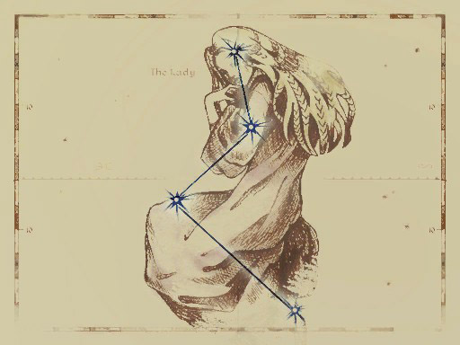

*The Lady is one of the Warrior's Charges and her Season is Hearthfire. Those born under the sign of the Lady are kind and tolerant.*

* *Trait*: **Lady’s Favor**

You gain a +5 to your Max Health.

* *Star-Cursed Trait*: **Lady’s Grace**

You gain an additional +5 to your Max Health but you take a -4 to your Carry Rating.

* *The Lord*

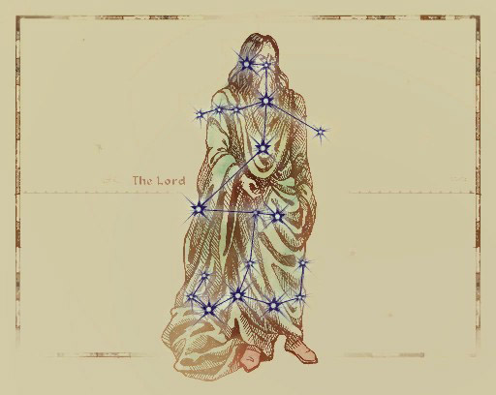

*The Lord's Season is First Seed and he oversees all of Tamriel during the planting. Those born under the sign of the Lord are stronger and healthier than those born under other signs*

* *Trait*: **Blood of the North**

You naturally restore 1d4 Health over short rests.

* *Star-Cursed Trait*: **Trollkin**

Whenever you naturally regain Health, you double the restored amount but gain Weakness (Fire, 4).

* *The Steed*

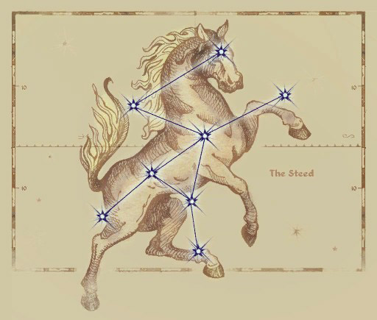

*The Steed is one of the Warrior's Charges, and her Season is Mid Year. Those born under the sign of the Steed are impatient and always hurrying from one place to another.*

* *Trait*: **Charioteer**

You gain +4 to your Move Speed.

* *Star-Cursed Trait*: **Beast of Burden**

You gain +4 to your Carry Rating but reduce your max Stamina by 1.

***Cultures***

***Dunmeri***

*“Fluff”*

***Synopsis***

Description/Details

***Cultural Skills***

* *Destruction*
* *Light Weapons*
* *Evasion*
* *Mysticism*
* *Alteration*
* *Illusion*
* *Marksman*
* *Awareness*
* *Lore*

***Cultural Traits (Choose One)***

* *Thrice-Blessed*

Living under the teachings of the three in your daily life has distilled their virtues within you.

**You gain a +2 to three different Attributes of your choice**

* *???*

?

***?***

* *???*

?

***?***

***Cultural Talent***

* ?

***Velothi***

*“Fluff”*

***Synopsis***

Description/Details

***Cultural Skills***

* *Destruction*
* *Survival*
* *Marksman*
* *Awareness*
* *Athletics*
* *Acrobatics*
* *Sneak*

***Cultural Traits (Choose One)***

* *Nomad*

The nomadic tribes of old Resdayn are accustomed to life on the move.

**You can maintain full rest benefits while traveling at any pace.**

* *Reclaimer*

The Velothi are a highly religious people that hold their beliefs as the truest faith among the Dunmer. This zealous determination can push them beyond their limits.

***Once per session, you can instantly regain the use of one Short or Long rest ability. X?X?***

* *Ashlander*

Many of the Velothi tribes reside in the scotched lands across Morrowind known as the “Ashlands.”

***Gain Resist Fire (1) and you only suffer half the penalty from the Heat-Stroke condition.***

***Cultural Talent***

* ?

***Altmeri***

*“Fluff”*

***Synopsis***

Description/Details

***Cultural Skills***

* *Alteration*
* *Restoration*
* *Conjuration*
* *Mysticism*
* *Illusion*
* *Destruction*
* *Lore*
* *Linguistics*
* *Artistry*

***Cultural Traits (Choose One)***

* *Arcane Supremacy*

The Elves of the Summerset Isles are known to produce the most gifted of mages.

**Increase your WpB by +1 for Spell Overload**

* *Phynaster’s Lesson*

The ancestor god Phynaster taught the Altmer to live longer by shortening their stride.

**Your Speed is reduced by 1, you gain +3 HP.**

* *?*

?

**?**

***Cultural Talent***

* ?

***Bosmeri***

*“Fluff”*

***Synopsis***

Description/Details

***Cultural Skills***

* *Marksman*
* *Light Weapons*
* *Unarmed*
* *Sneak*
* *Awareness*
* *Survival*
* *Animal Handling*
* *Acrobatics*

***Cultural Traits (Choose One)***

* *Pact Adherent*

The pact demands that no source of meat is to be wasted. No source at all.

**This functions as a Bond. You must consume a piece of every “Meat” source that you kill, that it would be possible for you to retrieve, within 24 hours of the kill. Doing so during a rest period restores +2 SP and 5 HP.**

* *Way of the Hunt*

The lives of the Bosmer is one where one must be willing to take a life to survive.

**You inflict +2 Damage vs. Beast type foes.**

* *Among the Green*

Moving through the forest canopy to avoid the various predators of the wild has taught you the benefits of moving quickly and silently.

**You cannot be tracked while moving alone through woodland environments. You may also conceal the passage of a Group of less than 10 people while traveling at a slow pace.**

***Cultural Talent***

* ?

***Nordic***

*“Fluff”*

***Synopsis***

Description/Details

***Cultural Skills***

* *Light Weapons*
* *Heavy Weapons*
* *Block*
* *Unarmed*
* *Marksman*
* *Survival*
* *Athletics*
* *Provisioning*

***Cultural Traits (Choose One)***

* *Northerner*

The harsh cold of your northern home has inured you to the biting winds.

***Gain Resist Frost (1) and you only take half the normal penalty from the Frostbite condition.***

* *Reveler*

The peoples of the north are no stranger to celebration.

***Partaking in revelous activity during a rest period restores 2 HP or +1 SP***

* *Warborn*

One could count the years Skyrim has spent in peace using their fingers, and maybe those of their foes.

***You inflict +1 to all Physical Damage attacks***

***Cultural Talent***

* *Woad*

***Bretonic***

*“Fluff”*

***Synopsis***

Description/Details

***Cultural Skills***

* *Riding*
* *Lore*
* *Linguistics*
* *Heavy Weapons*
* *Block*
* *Speechcraft*
* *Conjuration*
* *Restoration*
* *Alteration*

***Cultural Traits (Choose One)***

* *Chivalry*

The heirs of the Direnni hold a strong belief on valor, honor, and justice.

***When you uphold a Bond, you regain 2 Luck Points instead of 1***

* *Daily Magic*

The people of High Rock, both high and low, tend to use magic to perform several daily tasks.

**Increase your WpB by +1 for Spell Restraint**

* *A New Hill*

“Find a hill, become a king.” An old Breton proverb used to describe the Bretons drive for a better life.

**You gain +1 xp for “Successfully Resolving a Social Encounter” or “Completing a Major Campaign Objective” once per session**

***Cultural Talent***

* *Lionheart*

***Colovian***

*“Fluff”*

***Synopsis***

Description/Details

***Cultural Skills***

* *Heavy Weapons*
* *Block*
* *Speechcraft*
* *Awareness*
* *Riding*
* *Athletics*
* *Restoration*

***Cultural Traits (Choose One)***

* *Highlander*

Living in the high altitudes and mountainous terrains of Colovia have toughened you to arduous paths and marches.

***You gain +1 Max Stamina***

* *Legion Pride ???*

The people of Colovia are the heart and soul of the Red Legion. Their sense of unity leaves them willing to fight and die together, rather than falling apart.

***You start play with the “Teamwork” talent***

* *?*

?

**?**

***Cultural Talent***

* ?

***Nibenese***

*“Fluff”*

***Synopsis***

Description/Details

***Cultural Skills***

* *Speechcraft*
* *Mercantile*
* *Illusion*
* *Riding*
* *Medicine*
* *Lore*
* *Linguistics*
* *Destruction*
* *Alteration*

***Cultural Traits (Choose One)***

* *Cosmopolitan*

The people of the Niben frequently trade with many diverse groups, it makes it easier if you can talk.

***You begin play with one additional Language from the Common Tongues. Additionally, if you are speaking to someone in their “Native Tongue” you can reroll one failed Speechcraft or Mercantile skill test made against them. You can only reroll against the same target once per session***

* *Magocracy*

The highest regarded members of the Aristocracy of Nibenay are the Battlemages. This has led many of the Nibenese to idolize Mages and the practice of spellcraft itself.

**The time it takes to learn a new spell is halved and costs half to purchase.**

* *?*

?

**?**

***Cultural Talent***

* ?

***Forebear***

*“Fluff”*

***Synopsis***

Description/Details

***Cultural Skills***

* *Light Weapons*
* *Heavy Weapons*
* *Block*
* *Athletics*
* *Riding*
* *Medicine*
* *Awareness*

***Cultural Traits (Choose One)***

* *The Ra’Gada Spirit*

?

**?**

* *Desert-Dweller*

?

**?**

* *?*

?

**?**

***Cultural Talent***

* ?

***Crown***

*“Fluff”*

***Synopsis***

Description/Details

***Cultural Skills***

* *Speechcraft*
* *Mercantile*
* *Lore*
* *Riding*
* *Alteration*
* *Light Weapons*
* *Linguistics*

***Cultural Traits (Choose One)***

* *?*

?

**?**

* *?*

?

**?**

* *?*

?

**?**

***Cultural Talent***

* ?

***Argonia***

*“Fluff”*

***Synopsis***

Description/Details

***Cultural Skills***

* *Survival*
* *Sneak*
* *Evasion*
* *Athletics*
* *Marksman*
* *Alchemy*
* *Light Weapons*
* *Mysticism*

***Cultural Traits (Choose One)***

* *?*

?

**?**

* *?*

?

**?**

* *?*

?

**?**

***Cultural Talent***

* ?

***Khajiiti***

*“Fluff”*

***Synopsis***

Description/Details

***Cultural Skills***

* *Mercantile*
* *Sneak*
* *Security*
* *Awareness*
* *Acrobatics*
* *Unarmed*
* *Provisioning*

***Cultural Traits (Choose One)***

* *On Warm Sands*

?

**?**

* *Sweet Tooth*

?

**?**

* *Moonpaths*

?

**?**

***Cultural Talent***

* ?

***Orcish***

*“Fluff”*

***Synopsis***

Description/Details

***Cultural Skills***

* *Heavy Weapons*
* *Unarmed*
* *Block*
* *Survival*
* *Athletics*
* *Smithing*

***Cultural Traits (Choose One)***

* *War-Child*

You were raised by the War-Wife of your stronghold’s Chieftain. From a young age, she expected strength and would settle for nothing less.

***You gain +2 Max Health***

* *Hearth-Child*

Being raised by the Hearth-Wife had you working all day, running water, repairing structures, cooking, and aiding your kin in the mines.

***You cannot be slowed down by worn Armor and you reduce your speed penalty from being encumbered by 1***

* *Forge-Child*

Working alongside your stronghold’s Forge-Wife, you learned the craft of Malacath’s children.

***You start play with the “Orcish Design” smithing talent. You may also have 1 piece of starting equipment, be of Orcish Design***

***Cultural Talent***

* ?

***Skaal***

*“We are bound to this land, like a great pine with roots that run as deep as the tree is tall.”* - Frea, Skaal Shaman

***Synopsis***

Description/Details

***Cultural Skills***

* *Survival*
* *Awareness*
* *Sneak*
* *Marksman*
* *Medicine*
* *Restoration*
* *Heavy Weapons*

***Cultural Traits (Choose One)***

* *?*

?

**?**

* *?*

?

**?**

* *?*

?

**?**

***Cultural Talent***

* ?

***Reachmen***

*“Fluff”*

***Synopsis***

Description/Details

***Cultural Skills***

* *Conjuration*
* *Survival*
* *Marksman*
* *Light Weapons*
* *Evasion*
* *Destruction*
* *Alchemy*

***Cultural Traits (Choose One)***

* *?*

?

**?**

* *?*

?

**?**

* *?*

?

**?**

***Cultural Talent***

* ?

Future Cultures

* Ayleid
* Falmeri
* Dwemeri
* Maormeri
* Kennish
* Minotaur
* Tscaesi
* Glenmoril

***Traits***

Starting levels Max Bonus CrP

* Low: +10 /
* Mid: +15 /
* High: +20 /

***Positive Traits***

*Attractive*

***CrP Cost***: 3

The character is attractive and gains a +10 bonus to

any Personality test where their beauty plays a major

role in the outcome.

*Brave*

***CrP Cost***: 5

The character is lionhearted and does not scare easily. They gain a +20 bonus on Willpower tests to resist Fear or Intimidation.

*Danger-Sense*

***CrP Cost***: 4

The character has a sixth sense for danger. Any time the character is Surprised, they can choose to roll Initiative instead, but takes a -20 on all non-defensive reactions in the first Round of combat.

*Directional Sense*

***CrP Cost***: 2

The character has a good sense of direction, and can always find north when outdoors.

*First Impression*

***CrP Cost***: 3

The character makes a good impression, and gains a +10 bonus on any Personality test when first meeting someone new.

*Good with Animals*

***CrP Cost***: 3

The character has an affinity for animals and gains a +10 bonus on any Animal Handling test made to train or calm an animal.

*Pain Tolerant*

***CrP Cost***: 4

The character has a high threshold for pain, and gains a +10 to resist Wounds.

*Situational Awareness*

***CrP Cost***: 3

The character is hyper-aware of their surroundings, and can ignore any negative modifiers to Perception for being distracted, but not for poor lighting or environmental conditions.

*Strong Immune System*

***CrP Cost***: 5

The character has a strong immunity to common diseases and gains a +10 to Endurance tests made to resist or overcome a common disease.

*Acute Hearing*

***CrP Cost***: 4

The character has such an acute sense of hearing that they do not suffer any penalties due to distracting sounds to the Passive Awareness.

*Rapid Recovery*

***CrP Cost***: 5

The character is capable of recovering from wounds faster than their peers. The character doubles all HP they recover naturally. When stacked with the Star-Cursed Lord Birthsign, you triple your natural healing, not quadruple.

***Negative***

*Addiction to (X)*

***CrP Bonus***: +3

The character is addicted to some substance, such as alcohol, moonsugar, skooma, or even more alien or outlandish drugs such as feldew. Should the character not be able to indulge in the drug regularly (more accessible drugs require more frequent access), they suffer a -10 penalty on all tests, which increases in severity by an additional -10 to a maximum of -30 for each passing day until they get their fix.

*Aversion to (X)*

***CrP Bonus***: +2

The character is afraid of or averse to something (X). This can be used to represent a phobia, compulsive avoidance, or strong dislike of a certain thing. When exposed to their aversion, the character suffers a -10 on all tests.

*Combat Paralysis*

***CrP Bonus***: +2

The character has a habit of freezing in dangerous

situations. When rolling for Initiative, the character rolls twice and takes the lowest.

*Disturbing Voice*

***CrP Bonus***: +2

The character has an intimidating, disturbing voice. They gain a +10 bonus to Speechcraft tests made to intimidate, but suffer a -20 to all other Personality based tests that involve speaking.

*Illiterate*

***CrP Bonus***: +2

The character was never taught to read or write. They cannot read or write, obviously.

*Low Pain Tolerance*

***CrP Bonus***: +3

The character has a low threshold for pain, suffering a -10 penalty to resist the Shock Test inflicted by Wounds, as well as against any Willpower test to resist the effects of pain.

*Oblivious*

***CrP Bonus***: +3

The character is often oblivious to danger. The

character suffers a -20 on Perception based tests that

would determine if the character is surprised by an

enemy or not. The character also takes a -10 penalty to their Passive Awareness.

*Timid*

***CrP Bonus***: +3

The character is timid and scares easily. They suffer a -10 penalty on Willpower based tests to resist Panic

tests or intimidation, and a -20 penalty on Horror tests.

*Ugly*

***CrP Bonus***: +2

The character is ugly and suffers a -10 penalty to any Personality based tests where their appearance plays a major role in the outcome.

*Weak Immune System*

***CrP Bonus***: +3

The character has a poor immunity to common diseases and takes a -10 penalty to Endurance tests made to resist or overcome a common disease.

*Lingering Injury*

***CrP Bonus***: +4

The character has an old injury that comes back to bug them at the worst times. The GM and the player should work out the specifics of the injury, and how it affects the character. However, living with a painful injury has made the character tough, granting 1 Stamina Point to the character as powering through exhaustion and pain is everyday life for the character.

*Stunted Magicka*

***CrP Bonus***: +4

The character was born with a peculiar block to their connection to Aetherius, resulting in a -1 penalty to their max Attunement and they cannot naturally recover their Magicka.

***Special Traits***

All special traits must be permitted specifically by the Gamemaster. More will be added along with their applicable mechanics. (Such as Dragonborn, Dhampyr, and Giantkin)

*Noble Birth*

***CrP Cost***: 10

You are a child of noble birth and with that comes the privileges and burdens of such a station. Discuss the exact privileges and assets granted to you by your station and what responsibilities you may have.

A constant privilege is that you tend to be treated better by other nobles and many of the common folk would show their respect out of loyalty or caution, wanting to avoid the ire of the nobility. You also have access to a sizable family vault for financial aid, doubling whatever starting Gold you begin play with. On the other hand, your actions reflect upon your noble house and family. Failing to protect your honor and the honor of your kin may result in negative actions taken against you. Additionally, many nobles have their fair share of enemies and rivals that may cause issues for you.

***Bonds (As 3e)***

Bonds 0are short phrases that describe something unique about your character personality. They are not necessarily something that makes you a “bad person”, but something that can complicate your character’s life. Whether its a vendetta, a personality compulsion, a large debt, an inconvenient loyalty, or a forbidden love, Bonds should be thematic and resonate with your character to bring depth and more importantly, interesting and organic plot hooks.

*Example Bonds*

* Insatiable greed.
* A poor temper.
* A forbidden lover.
* A vow of pacifism.
* Large debts to an illegal organization.
* Being a wanted criminal.
* Holding a grudge.
* Insurmountable pride.

*Gaining Bonds*

During character creation, characters are encouraged to take a Bond or two. During the course of the game, the GM may prompt you to clear existing Bonds if they are resolved, or add new Bonds that arise throughout the course of the campaign.

*Exploiting Bonds*

If your character is in a situation where your Bonds

will inconvenience, harm, or otherwise make

a situation worse, someone, including you, can Exploit your Bond by describing how its relevant and offering a complication. In that case, you get two options:

* Accept the complication and gain +1 Luck Point.
* Spend a Luck to avoid the complication.